Handling tips for Catch and Release of a Musky
- A large net is the most important tool to have. It needs to be big enough to keep a good sized musky in the net, in the water next to the boat with it’s head in the water while unhooking and preparing to handle the fish.
- If the musky’s head is in the water in the net at the side of the boat, take your time there is no hurry, be careful. Unhook the fish, use mouth spreaders, hook cutters for tough hooks or those by the gills, use long handled pliers. Be careful musky hooks can send you to the hospital.
- Once unhooked leave the musky in the net, get your camera and measuring stick ready.
- Once everything is ready, carefully grab the musky by the gill plate, keep your hand to the outside of the gill flap as the gills have sharp rakers and they will cut your hand if not done properly. This is your handle and it will give you the best control of the fish if she wants to flop around on you. Don’t drop the fish in the boat, it is pretty tough on them.
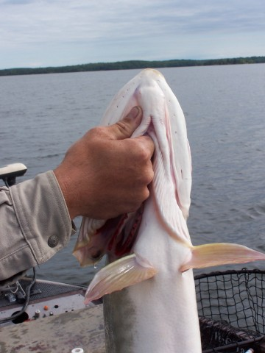
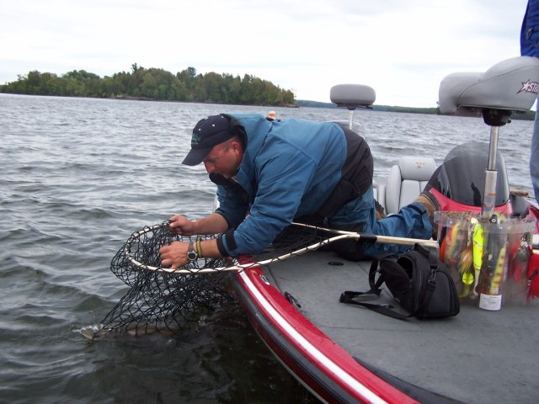
- Best rule of thumb is that a musky should not be out of the water any longer then you can hold your breath.
- Laying a fish on the bottom of the boat to measure is OK but get the floor wet first to protect the slime coating on the musky. Also, be careful to not let the fish flop around and get hurt. Keep the gill grab during this.
- Small muskies are as important to properly handle as big ones. Small ones usually have more energy and are tougher to handle.
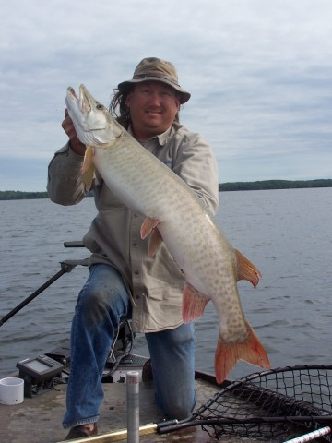
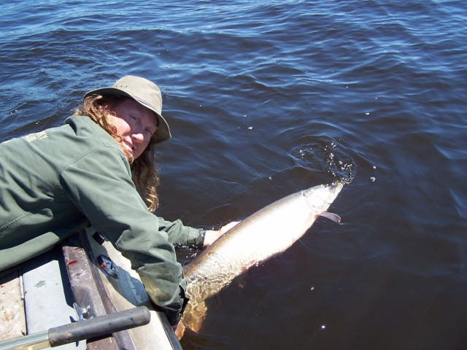
- Once the pictures are taken, gently set her back in the water and hold her by the tail. Slowly swim your hand a little side to side to get the fish going. When she is ready to swim off you will know. A few pictures during the release are awesome.

