Fishing Hall of Fame Validates Spray Musky
What follows is a detailed review of the reasoning behind
the Hall's decision to uphold Louie Spray's 1949 world record musky as the all-tackle world record musky:
- SUMMARY OF THE FORMAL PROTEST AND THE HALL'S DECISION:
Last October, a group known as the World Record Musky Alliance (WRMA) presented a report to the National Fresh Water Fishing Hall of Fame (NFWFHF) that alleged Louie Spray's 1949 world record musky had been falsified in size and should be expunged from the record books. After a careful and objective review of every aspect of the report during the past 3 months, the NFWFHF has ruled that the report lacks sufficient merit to overturn the Spray record.
The report's primary piece of evidence (which alleged that the Spray musky was only 53.6 inches long) came as a result of a computer software program that relied on multiple assumptions to be inputted before a result could be yielded. Because no control was ever done to test the approach that was used and so many assumptions had to be made, there exists too much reasonable doubt as to the accuracy of their result. In fact, while the report's primary photo analysis results prove to be inconclusive at best, other allegations contained in the report prove to be largely speculative, invalid, and, in many cases, outright false.
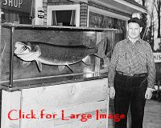
Spray with the mount of his 69 pounder
Countering the report's inconclusive results is much strong documentation supporting the size of the Spray musky. There are many sworn statements by credible witnesses; the mount of the fish was on public display for nine years; and the photos of this musky actually prove-through the use of same plane, direct scaling techniques that were employed by two professors of Mathematics (both of whom hold doctorates in Mathematics)-that the reported length of Spray's musky (63½ inches) is in the "ballpark" (the approximate range) of where it should be. It's important to note that: the same plane, direct scale techniques that were applied to the Spray photo have been subjected to a control test, which proved to be accurate to within three quarters of an inch, by the same two (above mentioned) professors.
The WRMA report claimed that Spray's 1949 world record musky-which officially weighed and measured in at 69 pounds 11 ounces, 63½ inches in length, and 31¼ inches in girth-only measured 53.6 inches long (plus or minus 1½ inches) and therefore couldn't have weighed anywhere near its reported 69 pound 11 ounce weight. It accused not only Spray, but also his fishing partners who witnessed the catching, measuring, and weighing of the fish (George Quentmeyer and Ted Hagg), the two other men who both swore that they had weighed and/or measured the fish (Postmaster Jack Reinke and Nick Barnes), and the taxidermist who mounted the fish (Hugh Lackey) as all being co-conspirators in an elaborate fraud to back up a false angling claim.
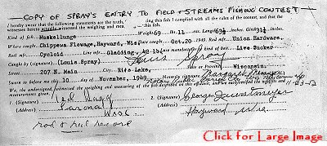
Field and Stream Entry for 69 Pounder
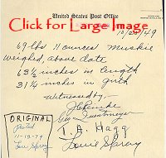
Weigh slip documenting weight and measurements
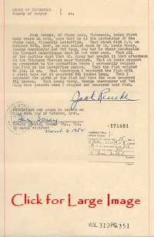
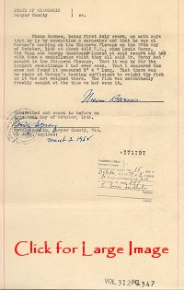
When it comes to reviewing a report of this nature-one that is essentially an accusation of fraud pointed toward six different individuals-it is an issue that the Hall is duty bound to take very seriously. There is no room for speculation and false statements in such a report, and it was only hard facts and provable statements that the Hall was looking for when they conducted their review. In any instances where so-called "scientific" evidence was introduced, the Hall looked carefully to see that such evidence was arrived at through a logical form of methodology, such as the "scientific method."
- WRMA REPORT FAILED TO FOLLOW THE SCIENTIFIC METHOD:
The WRMA report stated that they used "scientific methodology" to arrive at their various calculated results and conclusions; however, the report failed to follow one of the most basic principles of the scientific method-that of conducting a control experiment to test their various assumptions (hypothesis) and the results of their calculations (experiments). Before broaching this subject in more detail, we should briefly review exactly what the scientific method is.
The "scientific method" pertains to the principles that guide scientific research and experimentation, using objectivity and sound logic to arrive at a solution. The primary steps that make up the scientific method are: ask a question, formulate a hypothesis to assume a plausible answer to the question, design an experiment to test the hypothesis, do a controlled experiment to test the reliability of the results of original experiment, and come to a conclusion. One of the cornerstones of the scientific method is: for an experiment to give reliable answers, a control experiment must be conducted.
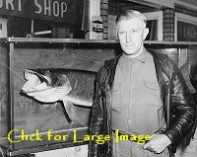
Hugh Lackey pictured with Spray's mounted 69 pounder
The WRMA report arrived at two of their primary conclusions without a control experiment ever having been conducted to test their conclusions. Specifically: 1) After the WRMA inputted various assumptions about the photos of the Spray musky into a computer software program to yield their result that the musky was only 53.6 inches long, they never conducted a control experiment on a musky of known dimensions to test the reliability of their result. 2) Later in the report, it was hypothesized that: because the body shape and fin placement of the mount of the Spray musky didn't exactly match the body shape and fin placement of the fish, the mount must have been altered or enlarged. However, a control experiment was never conducted to test their hypothesis by comparing the body shape and fin placement of various other muskies (that are known to be legitimate) with the body shape and fin placement their own mounts. If they would have conducted such a control test of their theory, the WRMA would have quickly discovered that the above mentioned observed differences do indeed occur on many other muskies that are known to be legitimate.
- ASSESSING THE SIZE OF MUSKIES OFF OF OLD PHOTOS IS OFTEN A MATTER OF PERSPECTIVE
Before getting into the discussion of the validity of the WRMA report's conclusions, it may be worthwhile to touch on the issue of why some people are, all of a sudden, questioning the size of Spray's record musky. Spray's fish has long been accepted as being 69 pound 11 ounces and 63½ inches long with, until only recently, little doubt ever being cast to dispute its size. Granted, the "rumor mill" has concocted many wild tales questioning HOW he had caught his fish; Spray was an easy target because he was such a colorful character. But why has it been only until recently that the SIZE of Spray's fish has been questioned. Simply put, it's likely just a matter of perspective.
During recent years, the practice of catching and releasing huge muskies-fish in the 45 pound class and beyond-has really begun to catch on. More frequently, the pages of our favorite fishing magazines are publishing photos of these big hulks being hefted by some proud angler just before they are released back into the water. These are impressive photos, to say the least, photos that may even appear to look like they are of record class fish. Such photos have made some anglers take pause and think, "Wait a minute, some of these huge fish look like they are just as big as some of the record muskies that were taken more than a half century ago.
These observations-although likely based more upon emotion than on logic-have made some anglers think that maybe some of the hallowed musky catches from the old days aren't really as large as originally claimed. There is a rational explanation for these perceptions, however. It's largely a matter of 21st century camera technology being used to photograph today's large released musky catches versus the antiquated photography of the 1940s that was used to photograph the huge kept muskies of yesteryear.
It's important to note that practically every one of today's musky catches has been photographed with a camera with-what can be defined as-a wide angle lens. A lens with a normal view, or one that pretty much matches what the human eye could see, is in the 50mm range. Anything smaller than that is considered a wide angle lens, with 35mm lenses and, more increasingly, 28mm lenses being commonly used. The smaller the number, the wider angle the lens is and the more the image of a photographed musky will be distorted to appear larger.
Wide angle lenses have been becoming more and more popular ever since the practice of releasing huge muskies began to catch on. They are made to order when you are confined in the relative close quarters of a fishing boat and want to photograph a friend's big musky before he releases it. This is one reason that many anglers are today opting to use the wider angle lenses like a 28mm. However, one consequence of using such a wide angle lens is that it skews most anglers' perceptions of how big a musky truly is. More often than not, an angler now associates a distorted image in his mind to correspond with a musky of a certain size. As a result, many of the musky catches from years ago may not appear to be as large as they are supposed to be.
- THE WRMA REPORT'S PRIMARY PHOTO ANALYSIS PROVES TO BE INCONCLUSIVE
The WRMA's conclusion is primarily built around photo analysis of two photos of the Spray musky that were taken shortly after it had been caught. This photo analysis, conducted by a Canadian firm who through a software program that is primarily used in automobile accident reconstruction cases, concluded that the Spray fish was only about 53.6 inches long. Obviously, this conclusion is seriously at odds with the strongly documented dimensions of the fish. After many weeks of inquiry into the matter and the consultation of many experts in the fields of photogrammetry and mathematics, the NFWFHF has discovered the likely reason for the discrepancy. Through no fault of the software program that was used, it was learned that the program could not have been used without a number of assumptions first being made about the scene in the photos. In fact, because nothing was known about the parameters of the camera that took the 1949 photos of the Spray musky, before the software program could be used to yield a final result on the length of the fish, an inverse camera calculation had to be done.
Inverse camera calculation
An inverse camera calculation is the process of computing camera parameters from the scene in a photograph using control points and constraints that are either known or assumed. Without doing the inverse camera calculation, as explained on the software program's own website, the software program could not have been used to yield a result on the length of the Spray musky. The software program's own website states, "To use inverse camera some information about the scene or object is required." It also states, "There are some strict requirements though and many photographs you come across cannot be used."
The website clearly states, in referring to using the inverse camera feature of the software program, "If you are using axes constraints, you have to have a photo with the correct perspective." In this circumstance, the website further explains that you can only do such a calculation (the inverse camera calculation), "if you have a strong two or three point perspective," or, in other words, two strong (reliable) vanishing points can be determined in the photo.
Vanishing points have to do with perspective and can be accurately plotted as long as there is a geometrically sound, two or three dimensional object or structure (like a building or part of a building) in the background of a photo. By geometrically sound, we mean that: 1) all of the visible horizontal line segments within the same plane of the structure must be known to be parallel to each other. 2) all of the visible vertical line segments within the same plane of the structure must be known to be parallel to each other 3) any planes that are adjacent to each other must be at right angles (or precisely at 90 degrees) to each other. The Laws of Perspective are basic rules of science that dictate the aforementioned to be true.
It should be noted that the same photo of Spray with his musky that was analyzed through the software program was examined by experts in perspective who scrutinized just how "reliable" the vanishing points in the photo really were. Bonnie Higgins, the Assistant Professor of the Department of Technological Studies at Bemidji State University in Minnesota stated, regarding this photo, "this photo has inconclusive evidence to establish a second vanishing point. It is difficult to determine what is perpendicular. The left vanishing point is firm, however the case for the right vanishing point is considerably weak." Likewise, Professor William Brown, Chairman & Professor of Art at the University of Evansville, Indiana, stated regarding the Spray photo, "there are two vanishing points that could be plotted on the eye level… However, due to the shortness of the line in the inside of the window and the fact that it is the only apparent line in the picture going to that second point, it is not considered a reliable source. Hence, I would say that the picture is based on one point perspective."
In the photos of Spray with his record musky, there is a section of a wall of a building with a rock foundation in the background. Nothing about this wall is known to be geometrically sound and it is at this early juncture in the calculation process (within the built in feature of the software program that does the inverse camera calculation) that multiple assumptions had to be inputted in order to use the software program to try to come up with camera parameter figures that were needed before they could proceed to allow the software program to "calculate" the length of the Spray musky.
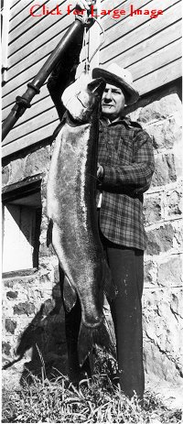
Louie Spray with his world record musky
Let's elaborate on the procedure a bit. In order for the computer software program to be able to conduct its internal inverse camera calculation and thus arrive at the required internal camera geometry (camera parameters) figures that were needed before the software program could be further used to determine the fish length, more than eighty marked points had to be manually plotted (and assumed) to form constrained lines. From these assumed constrained lines the software program was then able to complete its internal camera calculation of the Spray photos. When asked about how many assumptions were made in using the software program, the individual who inputted the information (Dan Mills) admitted, "That is an unanswerable question. Any marked point could be considered an assumption." Keep in mind, there were more than eighty marked points that had to be manually plotted; in other words, more than eighty individual assumptions alone were made just in this portion of the process. The fact that absolutely nothing about the wall in the background of the photos proves to be square, level, parallel, or perpendicular does indeed classify each one of the (above mentioned) marked points to be an assumption.
These marked points and the constrained lines that we are referring to (in the above section) represent the only information that the computer program had to go on in order to plot where it "thought" the vanishing points were located. Keep in mind that this software program can not even be used if there aren't at least two strong (reliable) vanishing points. When asked if he knew precisely where the vanishing points were located in the photos, Dan Mills had stated in writing that he didn't know where they were and that, essentially, the software plotted where the vanishing points were. In effect, the vanishing points were arrived at by making more than eighty separate assumptions.
One of the more critical examples that proves a lack of reliability for a second vanishing point (the right hand one) was the candid answer of Dan Mills to the following question: "In plotting the points and their resulting "horizontal" constraint lines for the old building that is pictured in the background in photos 10b and 10c on page 17 of the report, was it assumed that the visible line segment on the inside top corner of the bottom window was precisely perpendicular to the front face of the building and perfectly level as well?" His written response of, "Perpendicular, yes. Level, no," goes in hand with Professor William Brown's above statement regarding how unreliable the right hand vanishing point truly is.
Reliability of the report's final result
Once you begin inputting multiple assumptions into a software program, there are many different possible results that could be extrapolated. Even a spokesman for the company who makes the specific software program that was used to analyze the photos of the Spray musky, openly admitted that when trying to assess photos that have come from unknown cameras, "it is hit and miss as to whether or not the program will yield an accurate result." Referring to the hypothetical circumstance of assessing the size of objects off of photos, the spokesman went on to say that, if you are ever lucky enough to have a yardstick right next to the object that you are trying to measure in a photo, you wouldn't need to use a software program because doing a direct scaling would be all that you would need to do.
Although the software program that was utilized did indeed yield a result based upon the multiple assumptions that it was essentially fed, the arrived at result proves to be-at best-inconclusive. In fact, when asked if a control experiment was done to test the accuracy of this program with a fish of known size, it was learned that such a control test was never conducted. Clearly, the "scientific method" (which requires any hypothesis to be tested or proofed) was not followed in this matter, a hard fact that throws serious question into the validity of the conclusions that were yielded.
- SAME PLANE, DIRECT SCALING TECHNIQUE VERIFIES THE REPORTED SIZE OF THE SPRAY MUSKY
As mentioned previously in this statement, photos of the Spray fish clearly support the musky's reported size range when a same plane, direct scaling method is applied to the photos. The laws of Geometry allow such a calculation to yield quite accurate results. Furthermore, because the size of the fish is being checked against an accepted measurement that is in the same plane as the fish, we are eliminating the potential variable of perspective distortion from the calculation (in terms of the angler distorting the fish to be somewhat larger than it appears). The two mathematicians who scaled the length of Spray's musky from the photo were, Dr. Joseph Gallian, Professor of Mathematics at the University of Minnesota in Duluth who holds a PhD in Mathematics and is the president-elect of the Mathematical Association of America, and Dr. Dorian Goldfeld, Professor of Mathematics at Columbia University in New York who holds a PhD in Mathematics.
Using the same plane, direct scaling technique has long been utilized in the field of photogrammetry as a means of determining distances in photos. James O. Harris of Harris Technical Services in Florida explained that he has often used this technique in investigating auto crashes for his company. Harris summed up the procedure by stating that, before photographing a scene, you have to mark two points in the scene that are in the same plane of the object that you are seeking to get a measurement from. For reference, the distance between those two points is measured and recorded. The scene is then photographed, making sure that the marked reference points show in the photo. Once that is accomplished, a calculated measurement can be arrived at for the unknown object by scaling it directly off the photo, using the measured distance between the marked points on the photograph as a known.
This same plane, direct scaling method is precisely the method that was utilized by Professors Gallian and Goldfeld to calculate the approximate length of Louie Spray's 1949 musky. The known that was used to scale the length of the musky against was the distance that Spray's hand was above the ground (84 inches). This approximate distance is what the WRMA report and Dan Mills accepted as their foundation measurement in their calculation process. We at the Hall regard this to be a reasonable figure to use as a known and do not debate this point. Furthermore, Dan Mills has gone on record, in writing, stating that he considered Spray's right hand, the rope the fish is hanging from, the musky itself, and the ground directly beneath the fish to be all in the same plane. We at the Hall are also in agreement with this point. Because both parties are in agreement with these two accepted knowns, we then felt comfortable to proceed with having the two Doctorates of Mathematics evaluate the length of the Spray musky by using the same plane, direct scaling method.
Before a direct scaling could be done off the Spray photo, we had to know precisely between what portions of the two squares with the letter "s" in them in the photo (the one on page 20 of the WRMA report) represented the distance that Spray's hand was above the ground: a distance that is accepted by both parties to be 84 inches. Because it was not known at the time that Dr. Gallian and Dr. Goldfeld conducted their calculations as to what portion of the boxes to use as the endpoints of that distance, they did two sets of calculations: one using the outer edges of those two boxes and one using the inner edges of those two boxes. Their calculations reflect that approach.
As it turned out, the WRMA researcher (Dan Mills) later indicated that a small + sign at the top left of each box pin-pointed the precise end points of that distance. Using the mean (or average) of the professors' results is equivalent to that distance.
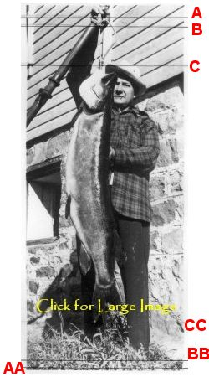
This illustrates the endpoints of measurement that were used when the direct scaling method was conducted by the professors.
The professors' two sets of results were also expressed in a range that used both 84 inches and 87 inches as the known figure to represent the distance that Spray's hand was above the ground. Because the high end of their two ranges reflect the size of the musky based upon using 87 inches as the known, that result can be disregarded. What remains are two sets of results for each of their calculations of the visible portion of the musky, based upon using, 1) the outer edges of the boxes as their endpoints and, 2) the inner edges of the boxes as their endpoints. The mean (or average) of each of their two figures represent their final calculation of the length of the Spray musky, based upon using 84 inches as the accepted distance that Spray's hand is above the ground.
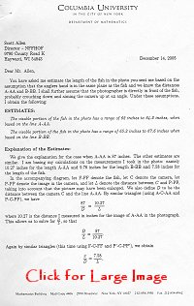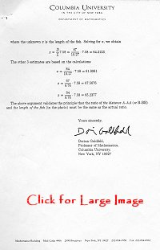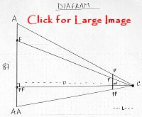
Dr. Gallian's calculation for the visible portion of the length of the Spray fish in the photo was the average of 61.125 inches and 64.375 inches or 62.75 inches and Dr. Goldfeld's calculation for the visible portion of the length of the Spray fish in the photo was the average of 62 inches and 65.2 inches or 63.62 inches.
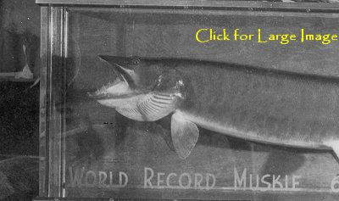
The mount of Spray's 69 pounder more
clearly shows the full length of the head of the fish
A very important fact to keep in mind when assessing the length of the Spray musky in this specific photo is that-because the head of the musky is tilted away from the camera in the photo-the entire length of the musky is not visible. People have sometimes commented that they thought the head of Spray's musky appeared to be small, but that was only because of the way that it is hanging. One look at the mount of the musky shows that it indeed had a normally proportioned, much longer, head. How much of the Spray musky's length is not visible in the photos? Most likely, there is at least 2 to 3 inches of "head length" not visible in the photo.
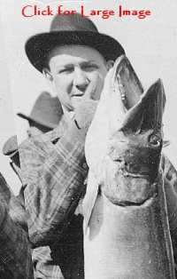
Two good examples that show the
full head length of a typical musky

Control Photos
As stated earlier, the same plane, direct scale techniques that were applied to the Spray photo have also been subjected to a control test (conducted by the same two, above mentioned, professors) which proved to be accurate to within three quarters of an inch.
As a control test of the methodology that the professors followed to calculate the approximate length of Spray's musky (as discussed in the previous section), the Hall decided to test the accuracy of their approach by giving the professors a control photo that closely duplicated the characteristics of the original Spray photo. The control photo was created jointly by three members of the Hall's board and one employee of the Hall who used a mounted musky from the Hall's museum that measured 51 inches long. This measurement remained the unknown that the professors had to calculate.
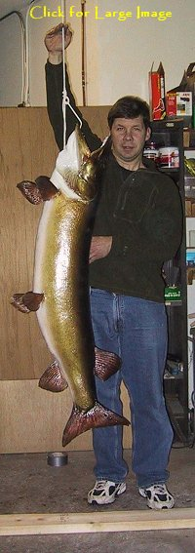
Control Photo
The musky was then hung from a rope above the floor, with a subject standing behind the fish and holding his hand at a point on the rope that was 81 inches above the floor. The point on the floor directly beneath the fish was marked by placing a board on the floor, with the front edge of the board being precisely positioned at that point. Therefore, the rope, the fish mount, and the point on the floor directly beneath the fish were all arranged to be in the same plane. Next, the scene was photographed from a crouched position, at a similar camera level (about 30 inches above the floor) that was used to photograph the Spray musky.
The control photos were then sent to Dr. Gallian and Dr. Goldfeld and they proceeded to use the same plane, direct scaling technique (which they had used to calculate the length of the Spray musky) on the control photo to determine the length of the mounted musky. The only knowns they had were that the distance that the subject's hand was above the floor was between 80 and 82 inches and that the subject's hand, the rope, the fish, and the point on the floor beneath it were all in the same plane.
Both professors' results were within three quarters of an inch of the true measurement of the mounted fish. Based upon the subject's hand being 80 to 82 inches above the floor, Dr. Gallian's calculated range for the length of the musky was 50.875 inches to 52.125 inches or averaged out to be 51.5 inches to reflect the 81 inch distance. And based upon the subject's hand being 80 to 82 inches above the floor, Dr. Goldfeld's calculated range for the length of the musky was 50.837 inches to 52.108 inches or averaged out to be 51.472 inches to reflect the 81 inch distance.
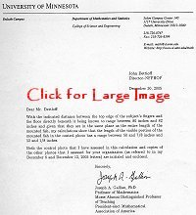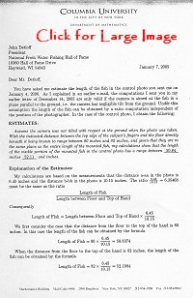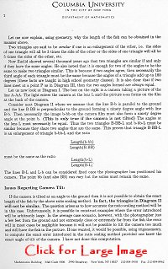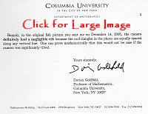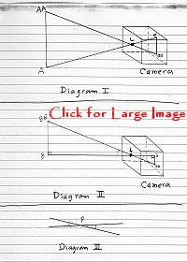
A parallel plane/tilted plane
control photo exercise that you can try at home
When it came to testing the same plane, direct scaling method by doing a control photo experiment, members of the Hall's board explored the matter more deeply on their own by conducting their own simple control experiment that produced an outcome that paralleled the findings of the control that was done by Professors Gallian and Goldfeld.
For this control experiment, seven differently colored, twelve inch plastic rulers were taped to a board, end to end, until there were precisely seven feet (or 84 inches) of rulers. Because they were all different colors, it was easy to see each individual ruler, or twelve inch segment, that made up the seven foot long reference measurement. In this control experiment, the seven foot long "ruler board" was positioned three different ways to see if a tilt in the subject (or, for that matter, the camera) would have any noticeable effect on the final results when using the same plane, direct scaling method.
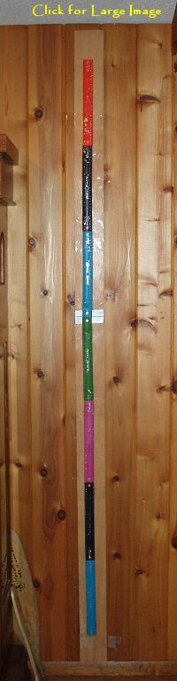
parallel plane arrangement
In Position #1, the board was taped flat against a wall and then photographed. (This "parallel plane" arrangement will be known as Photo set A.) In Position #2, the "ruler board" was put at a 12 degree angle and leaned against the wall, with its bottom approximately 20 inches away from the wall. (This "tilted plane" arrangement will be known as Photo set B.) Finally, in Position #3, the bottom four feet of the "ruler board" was secured nine inches away from the wall and parallel to it, while the top three feet of the "ruler board" was bent toward the wall so that the top end of it was actually leaning on the wall. (This "bent plane" arrangement will be known as Photo set C.)
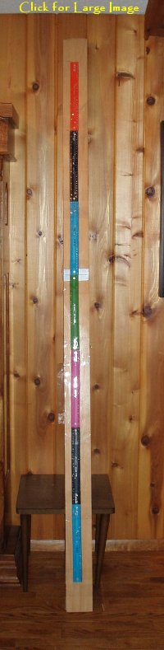
tilted plane arrangement

bent plane arrangement
The goal of this control test was to use same plane, direct scaling to calculate the distance that includes the five inner rulers by scaling it off of the known distance of 84 inches that includes all seven rulers. Naturally, we already know that the five inner rulers measure precisely 60 inches; however, this exercise is strictly for the purpose of testing the accuracy of using the direct scaling method when we start tilting or bending the plane that our subject is in. The beauty about this control experiment is that you don't even need a "scientist" to check up on how accurate the results will turn out. The seven plastic rulers make this experiment basically impossible to mess up. Please print out these photos and try it for yourself.
First, take a measurement off of the photos that includes all seven rulers; next, take a measurement off of the photos that includes the five inner rulers; and, lastly, use a simple ratio to calculate the length of the unknown (in this case, the distance that includes the five inner rulers) by using the distance that includes all seven rulers as the known of 84 inches. It's interesting to note that the tilt factor hardly has any affect at all on the final results.
For the "parallel plane" arrangement on Photo set A, the distance that includes the five inner rulers calculated to be 60.42 inches. For the "tilted plane" arrangement on Photo set B, the distance that includes the five inner rulers calculated to be 60.39 inches. And for the "bent plane" arrangement on Photo set C, the distance that includes the five inner rulers calculated to be 60.83 inches. It's interesting to note that the calculated length of the five inner rulers when using the same plane, direct scaling method on these "parallel plane/tilted plane" control photos was accurate to within 7/8 of an inch in all three photo sets. The issue of tilt had a negligible effect on the final results.
- THE "NEWLY DISCOVERED" PHOTO OF SPRAY'S WORLD RECORD MUSKY
The photos of Louie Spray's world record musky were most likely taken the day after he had caught his fish, presumably by reporters, in front of the wall of a building. There are three different known photos that were taken of Spray with his fish at that time. The "official" photo shows a clear, full length view of Spray and his fish, another photo is a bit grainier and had been cropped (at some point later) just below the musky's tail, and a third pose of Spray with his fish had been published in a couple of the newspaper articles right after it was caught.
After Spray had taken his fish to the taxidermist to be mounted, an outboard motor company did a photo shoot with Louie Spray and his fishing partners at Herman's Landing, for the purpose of promoting their motors. Although the musky was already skinned out and was not available, the photographers took various photos of the men. Later, they took a photo that they had taken of Ted Hagg standing alone in front of some trees and superimposed the image of Louie Spray with his fish onto the photo (in position right next to Hagg). This happens to be the only photo of Spray with his fish that showed the position of his feet. We will refer to this the "new photo."
This photo (the "new photo") was acquired in the mid 1970s by Paul Albrecht, the man who published Spray's 1980 autobiography. This photo was then put into storage with Albrecht's other materials from the book project and it wasn't rediscovered until late last November by Hall board members. Because this photo more clearly showed Spray's full height better than any other, the Hall had two Professors of Mathematics use direct scaling to calculate the maximum size of the visible portion of the image of the musky off of the photo.
Granted, Spray was not in the same plane as his musky and there will be some amount of distortion that will make the fish appear somewhat bigger than it really was. However, because it appears that Spray wasn't very far behind his fish and, in fact, his left side appears to be close to being in the same plane of the fish, the distortion factor shouldn't be very large.
How much distortion could there be? Obviously, that is somewhat of a guess. However, the Hall has in their files a 14 year old control distortion photo study that shows that the approximate rate of distortion when the camera is thirteen feet away from its subject is: for every inch that a person is behind a musky, the fish is distorted to appear only 4/10ths of an inch larger than it really is. In that case, if a musky would be held six inches out in front of an angler, then the fish would be distorted to appear approximately 2½ inches longer than it really was.
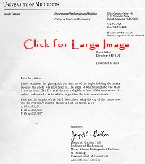
Endpoints that were used in Professor Gallian's calculations
Professor Gallian, who also did the direct scaling calculations for the Hall that were mentioned earlier in this report, calculated the visible portion of the length of the Spray musky in the "new photo" to be 62.25 inches. Remember, this calculation does not include any part of the musky's head that is not visible. He then calculated the total length of the Spray musky by measuring a bit above the musky's head (or lower jaw), to an estimated minimum and maximum location of where the hidden jaw should be. Dr. Gallian's measurements to each of those two points put his calculated total length of the Spray fish to range between 63 15/16 inches and 65 15/16 inches. Even after subtracting 2 to 4 inches for the distortion factor, this is certainly in the "ballpark" of the reported length of the fish.
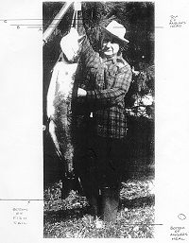
This illustrates the endpoints of measurement that were used when the direct scaling method was conducted by the professors.
Another Professor of Mathematics who conducted a calculation of the visible portion of the length of the Spray musky was a Professor Douglas Arnold of the University of Minnesota in Minneapolis. He summed up his calculations by stating, "Thus the only conclusion that we can draw with certainty is that the fish is shorter than 63 inches, perhaps considerably so." Although the last portion of his statement is speculation, the factual portion of his statement is right in line with Dr. Gallian's conclusion, in that Dr. Arnold refers to the length of the (visible portion of the) fish as being as much as 63 inches long. However, because Dr. Arnold didn't seem to realize that not all of the fish was visible in the photo, his answer may be a bit misleading to some.
- THE WRMA REPORT'S MOUNT ANALYSIS
A second portion of the WRMA report compared the ratio of the calculated (clearly visible) total jaw length and total fish length measurements that were taken off of the photo of the mount of Spray's 1949 musky to the ratio of the partial jaw length measurement and their report's inconclusive calculated length of 53.6 inches from the actual photo of the fish. (Please note that: the measurement of the musky's jaw length in the actual photo of the fish only includes a partial jaw length because the musky's head is tilted away from the camera in the photo and is partially hidden from view.) The Hall has found this entire section to be invalid because here they are essentially comparing the ratio of two known measurements to the ratio of two unknown (or inconclusive) measurements. (Please note that, in this section of the report, the WRMA accepts the mount of Spray's musky to be in the 62 to 63 inch range and this is what they have based their mount measurements upon).
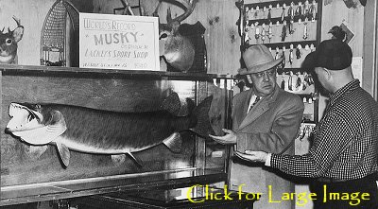
Ted Hagg and Louie Spray with the world record mount
- THE WRMA REPORT'S THEORY THAT SPRAY'S MOUNT HAD BEEN ALTERED PROVES TO BE INVALID
A third section of the report consists of a mount analysis whereby, perceived differences in the photos of the mounts versus the photos of the fish right after they had been caught (regarding the shape and fin placement of the fish) led the authors of the report to incorrectly assume that perhaps the mounts had been altered and enlarged. Once again, this hypothesis was never subjected to a "control test" to check if the same observed differences have also occurred when comparing known and verified fish with their own mounts. The NFWFHF did conduct their own inquiry into this matter and
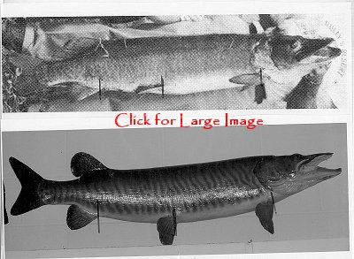
One of many examples of a verified musky that doesn\'t match
its own mount, relative to fin placement.
have discovered that a number of known legitimate musky catches also do not match their own mounts relative to shape and fin placement. Taxidermy is merely an artist's representation of a fish and the same observed differences that were brought out by the report prove to occur in many other muskies that are known to be legitimate; therefore, the accusations leveled at Spray's record musky in this section prove to be invalid.
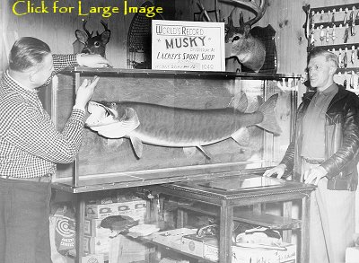
Spray with taxidermist Hugh Lackey and the record musky
- OTHER ACCUSATIONS MADE IN THE REPORT
The bulk of the remainder of the WRMA report is full of innuendo, false assumption, and incorrect statements that basically serve as nothing more than an unfair character assasination against Louie Spray and all of the witnesses who had any involvement with his fish. One of the report's more glaring incorrect statements assumes a patently false motive that Louie Spray had falsified his fish claims for substantial monetary gain. This false statement is not only in the report, but it has also been reiterated a number of times by the WRMA to the media during the past two months erroneously stating that, Louie Spray "discovered a system to turn big muskellunge into cold hard cash."
It wrongfully accused Louie Spray of falsifying his record claims for the purposes of garnering a significant financial windfall, stating, "His 1939 record alone netted him a cash prize of $3,000." The report went so far as to extrapolate that figure into today's dollars, stating, "this single cash prize would today represent over $23,000.00" The fact is, Louie Spray didn't receive any cash for that fish, but rather $30 in merchandise from National Sportsman magazine. This is but one example of how the report has unfairly influenced the readers of the report with incorrect information.
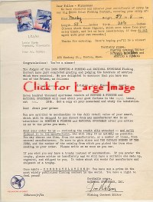
Documentation showing that Spray only received $30 in merchandise
(and not any cash) for his 59 pounder world record musky
- THE SUPPORTIVE DOCUMENTATION BACKING UP THE SPRAY MUSKY
Besides the fact that the NFWFHF has ruled that the WRMA report fails to produce any conclusive evidence that supports their protest, they are retaining Louie Spray's 1949 world record musky as their all tackle world record musky because there exists overwhelming documentation which shows that the Spray musky is actually one of the best documented world record fish in their record books. There are ten sworn affidavits supporting the Spray musky; there are good photos of the fish that substantiate its size; and the mount of the fish was viewed and scrutinized by literally thousands of people over a nine year period.
The sworn statements verifying the Spray
musky serve as very hard documentation.
  - Postmaster Jack Reinke of the Stone Lake Post Office swore under oath on an affidavit that he had personally weighed and measured Spray's 1949 record musky in the presence of Spray's fishing partners, Ted Hagg and George Quentmeyer (who also swore under oath on their own affidavits that they had witnessed Reinke's weigh-in). Reinke, a man held in high regard in the Stone Lake community, swore that he had personally: weighed the musky in at 69 pounds 11 ounces, measured the fish at 63½ inches long, and measured the musky's girth at 31 ^{1/4} inches. Although Reinke knew Louie Spray, he was not one of his friends nor was he even considered part of the Hayward community. Quite the contrary, especially during that period in time, the residents of the village of Stone Lake were a very close knit group who, essentially, viewed people from Hayward as "outsiders."
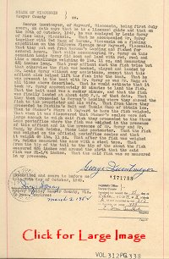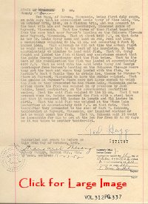
  - Another individual who swore under oath that he had also measured Spray's 1949 record musky was Nick Barnes, a carpenter at Herman's Landing who happened to be one of the first people to see Spray's fish after it had been brought in. Barnes swore under oath on an affidavit that, while the fish was there at Herman's Landing, he had personally measured the fish and found it to be 64 inches in length.
  - Six other witnesses who all swore under oath that they had witnessed the Spray musky and that the fish appeared to be a freshly caught fish were Herman and Edna Ceranske, Charlie Pastika, Jake Jordan, Milton Stroner, and Karl Kahmann.
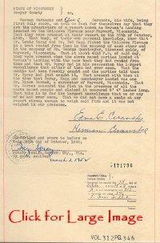 | 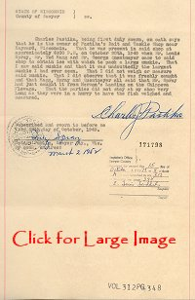
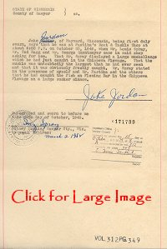 | 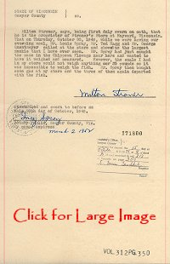
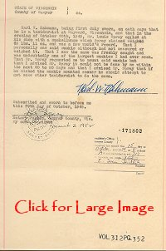
  - The taxidermist who mounted Louie Spray's 1949 record fish, Hugh Lackey, a stranger to Spray who ran a sport shop in the Wausau, Wisconsin area, swore under oath that he had done an internal examination of the stomach contents of the fish and found no artificial weight or foreign objects inside the fish. Lackey completed the mounting of the Spray musky in only 25 days. According to Lackey's wife, because he considered the fish to be of such importance and thought it should be painted just right he contracted a taxidermist and artist from the Milwaukee Public Museum (most likely William Schultz) to paint the fish.
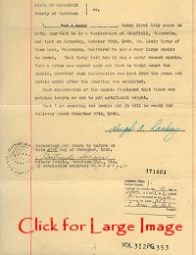
The mount of the Spray 69 pound 11 ounce world record musky was put on public display alongside Cal Johnson's mounted 67½ pound world record musky at the Milwaukee Sentinel Sport Show in 1950, where it was photographed and witnessed by literally thousands of people. Incidentally, photos taken of the display clearly show that the Spray mount was noticeably longer than the Johnson mount, a fish which is still on display today. Spray's fish remained on public display for the next nine years, until it was destroyed in a fire in Spray's real estate office in Rice Lake in 1959.
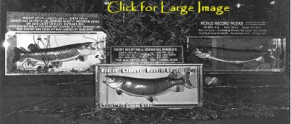
Louie Spray's 1949 world record mount picture
besides Cal Johnson's 1949 world record mount in 1950
In additional to the ten above mentioned sworn witness affidavits, the Hall also conducted a video taped interview with Leonard Dorazio who vividly recalled witnessing Spray's fish at Herman's Landing shortly after it had been brought in. Dorazio stated in the interview that the musky had obviously been freshly caught and that he remembered it being clearly over five feet long because it was as tall as him at the time.
- WHAT ABOUT LOUIE SPRAY'S OTHER TWO WORLD RECORD MUSKIES?
Some people may be wondering why the NFFHF has only made an official ruling on Louie Spray 1949 world record musky and not his other two world record muskies. After all, the WRMA report also made allegations that these other two fish had been exaggerated claims as well.
The reason the Hall made an official ruling on only Spray's 1949 world record musky is that it is not our duty to officially maintain a ranking list for each specie of fish, rather we only list the largest fish in each of our record categories. So, although the Hall hasn't seen anything in the WRMA report to indicate that Spray's first two record muskies had been false claims, we will not be making an official ruling on these fish.
In retrospect, Louie Spray's world record musky is likely the most scrutinized musky ever caught. Some may never want to believe in the musky and, perhaps, that goes with the territory whenever one talks about such a fantastic accomplishment or happening. However, the fact remains that Louie Spray's 1949 world record musky is exceptionally well documented and the NFWFHF is confident that the fish was as big as claimed.
For more detailed information about the Hall's decision to retain the Louie Spray world record musky, please contact Emmett Brown, Executive Director of the National Fresh Water Fishing Hall of Fame at 715-634-4440.

