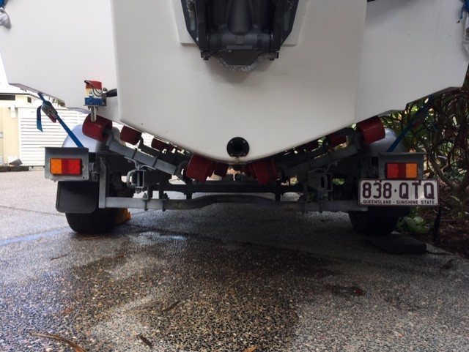
22°

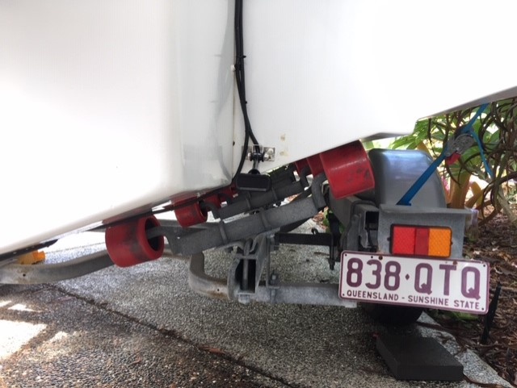
Strake
New Sonar transducer location
Relocate sounder transducer and replace with structure scan transducer.

Strake
Sonar
Structure Scan
22°
POD

